CAM PHUC PRIMARY SCHOOL  ---------***-- --------  Full Name : .................................  Class : 5..... |  |  |  | THE SECOND SEMESTER TEST  SUBJECT: ENGLISH - GRADE: 5  School year: 20….. – 20……  (Time : 40 minutes)
 | Skill | Listening | Reading |  | Writing | Speaking | Total
 | Mark
 | Remark | ……………………………………………………………………………
PART I: LISTENING
Task 1: Listen and number. (1 point)
A.  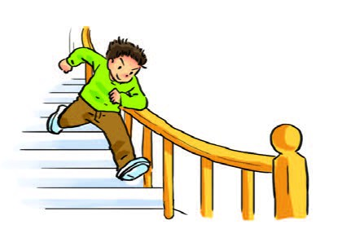 | B.  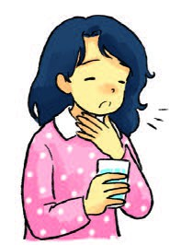 | C.  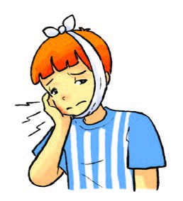 | D.  
Task 2: Listen and tick (V) the box. (1 point).
1.A.   | B.   | C.  
2.A.   | B.   | C.  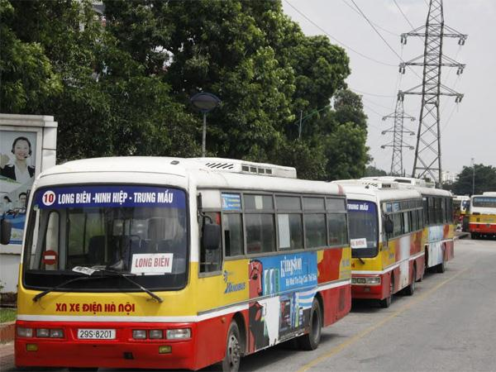
3.A.   | B.   | C.  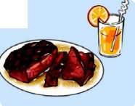
4.A.   | B.   | C.  
Task 3: Listen and complete. There is one example. (1 point).
Hi. My name is Phong. In my (0) free time, I often (1) go ……… with my friends because I like sports very much. My father likes sports, too. He (2) does …….. twice a week. My mother doesn’t like sports. She likes shopping. She often (3) goes…………… at weekends. And my sister likes housework. She often (4) ……………the house in her free time.
PART II: READING AND WRITING
Task 4: Look and read. Write the correct words next to their descriptions. There is one example. (1 point)
  teacher | 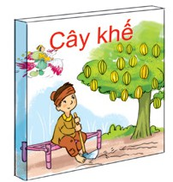  The Golden Starfruit Tree | pilot |   knife | 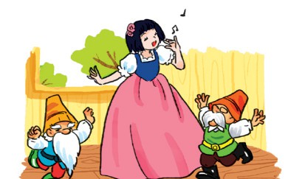  Snow White
0. She teaches in a school. teacher
1. He would like to fly a plane. __________
2. She helps Seven Dwarfs. She is beautiful and kind. __________
3. You shouldn’t play with it because you may cut yourself. __________
4. The story is about two brothers. The older brother is very greedy. __________
Task 5 . Read and tick  True or False. (1 point)
My name is Lien. I live in Ha Noi, the capital city of Viet Nam. The city has a lot of tall buildings and wide roads. It is noisy and busy all day and night. Every summer, I go to Tam Dao, a town in Vinh Phuc Province, about 86 kilometres from Ha Noi. Tam Dao is smaller and quieter than Ha Noi. But it has a cool weather all year round like Da Lat. There are not many shops, but things are cheaper. I enjoy eating fresh vegetable and chicken here. These are delicious and healthy foods. I like breathing fresh air here, too. Life in Tam Dao is more peaceful than in Ha Noi.
 | True | False
0. Lien lives in the capital city of Viet Nam. |  | 
1. There are many tall buildings and wide roads in the city.
2. Ha Noi is usually noisy and busy in summer.
3. The weather in Tam Dao is often cooler than in Da Lat.
4. Vegetable and chicken are fresh and healthy foods in Tam Dao.
5. Lien enjoys the fresh air in Tam Dao.
Task 6. Read and number the sentences in the correct order. The conversation begins with 0. (1 point)
 | A | Mai: I think I will visit Cuc Phuong National Park.
0. | B | Hoa: Where did you go last summer holiday, Mai?
 | C | Mai: Yes, I did. It was more interesting than I expected.
 | D | Hoa: Wow, to the beach? Did you like the trip?
 | E | Mai: I went to the beach with my parents.
 | F | Hoa: How about this summer? Where would you like to visit?
Task 7: Look at the pictures. Read and write ONE word in each gap for each picture. There is one example. (1 point)
My name is Quan. There are four people in my family. I usually  (0) go fishing in my free time. My mother is a  (1) ……….. in Cam Giang hospital. She usually  (2) …………the house in her free time. My father is an  (3) …………………….. He often  (4) …………football in his free time.
Task 8. Look at the pictures. Read and write one word for each gap. There is one example. (1point)
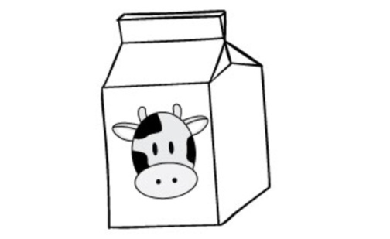
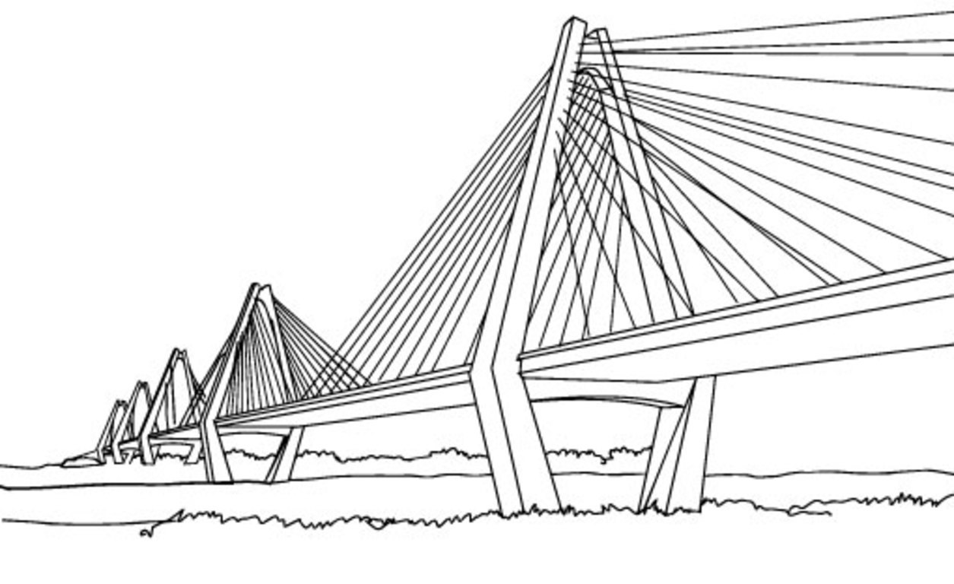  0.Nhat Tan bridge is very beautiful at night. | 1.I’d like a _______________ of milk, please. |   2.It will be _______________ tomorrow.
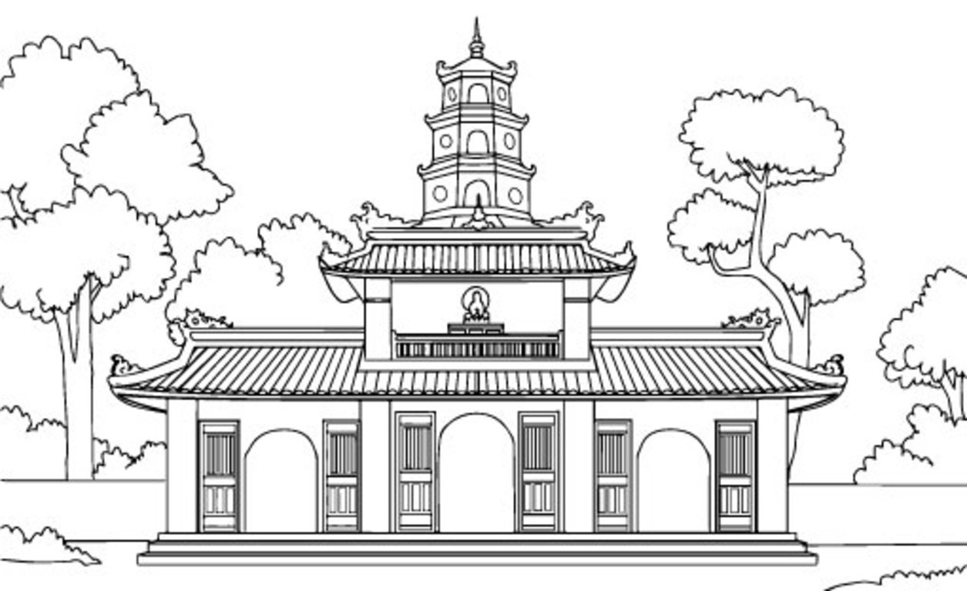  3.Thien Mu is an old  ____________ in the city of Hue. | 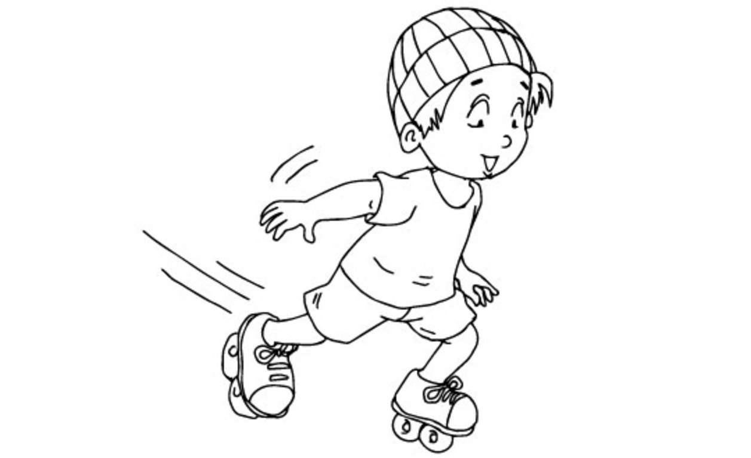  4.My brother goes ___________ every Sunday.
Task 9: Reorder the words to make sentences. There is one example. (1 point)
0. busy / Hai Phong / is / and / noisy.
Hai Phong is busy and noisy.
1. summer/ in/ like/What’s/ country/your
……………………………………………………………………………………….
2. country. / my / There / seasons / four / are / in
………………………………………………………………………………………
3. the hospital. / is / between / The / and / the cinema / supermarket
………………………………………………………………………………………
4. weather/ be/ what / the/ like/ tomorrow/ will/?
……………………………………………………………………………………….
PART III. SPEAKING (1 point)

---------------------------The end--------------------------

PART III: SPEAKING
Task 1: Getting to know each other. (0,5 point)
1. How are you today?
2. What time do you go to school every day?

Task 2: Talking about you would like to be in the future. (0,5 point)
1. What would you like to be in the future?
2. Why would you like to be ……..?

Task 3: Talking about seasons and weather in Viet Nam. (1 point)
(Teacher may use suggested questions if needed: How many seasons are there in Viet Nam? … )

-------------------------------The end----------------------------

Task 5. Read and tick True or False. There is one example (0). (1 point)
Key: 1. True 2. False 3. False 4. True 5. True
Task 6. Read and number the sentences in the correct order. The conversation begins with 0. (1 point)
Key: 1. E 2. D 3. C 4. F 5. A
Task 3. Read and fill each gap with one word from the box. Write the word next to the number. There is one word that you do not need. (1 point)
Key: 1. buses 2. supermarket 3. walk 4. reading 5. Writer

Hướng dẫn chấm Tiếng anh 5
PART I: LISTENING (3 points)
One correct question is 0,25 point.
Task | Answer |  |  |  | Point | Total
1 | 1 - C | 2 - A | 3 - D | 4 - B | 0,25/each | 1 point
2 | 1 - A | 2 - B | 3 - B | 4 - C | 0,25/each | 1 point
3 | 1 - go skating | 2 - does karate | 3 - goes shopping | 4 - cleans our house | 0,25/each | 1 point

PART II: READING AND WRITING (6 point)
One correct question is 0,25 point.
Task | Answer |  |  |  | Point | Total
4 | 1 - pilot | 2 - Snow White | 3 - knife | 4 - The Golden Star fruit Tree | 0,25/each | 1 point
Task 5. Read and tick True or False. There is one example (0). (1 point)
Key: 1. True 2. False 3. False 4. True 5. True
Task 6. Read and number the sentences in the correct order. The conversation begins with 0. (1 point)
Key: 1. E 2. D 3. C 4. F 5. A
One correct question is 0,25 point.
Task | Answer |  |  |  | Point | Total
7 | 1 - doctor | 2 - cleans | 3 - architect | 4 - plays | 0,25/each | 1 point
8 | 1.packet | 2. rainy | 3.pagoda | 4. skating | 0,25/each | 1 point
Task 9: Reorder the words to make sentences. There is one example. (1 point)

PART III: SPEAKING (1 point)
Task 1: Getting to know each other. (0,5 point) (One correct question is 0,25 point.)
1. I’m very well, thank you.
2. I go to school at ……………………..
Task 2: Talking about what you would like to be in the future. (0,5 point) (One correct question is 0,25 point.)
1. I’d like to be a/an …………………
2. Because I’d like to ………………………………….
Task 3: Talking about seasons and weather in Viet Nam. (1 point)
(Teacher may use suggested questions if needed: How many seasons are there in Viet Nam? .. )
PART I: LISTENING.
Task 1: Listen and number. (1 point)
1. Mai: What’s the matter with you, Nam?  Nam: I have a bad toothache.  2. Phong: I’m going to run down the stairs.  Tom: Don’t do it.  Phong: Why not?  Tom: It’s dangerous.  Phong: OK. | 3. Linda: What would you like to be in the future, Phong?  Phong: I’d like to be a pilot. I would like to fly a plane.  4. Mai: Hello?  Tony: Hi, Mai. It’s Tony.  Mai: Sorry. I can’t hear you.  Tony: It’s Tony. It’s Tony.  Mai: Oh, Tony! What’s the matter with your voice?

Task 2: Listen and tick (V) the box. (1 point)
1. What would you like to eat?  I’d like an apple, please.  2. Tony: Where’s West Lake, Nam? Is it far from here?  Nam: Yes, quite far. Do you want to go there?  Tony: Yes, I do. How can I get there?  Nam: You can take a taxi. | 3. Assistant: Are you ready to order?  Tony: Yes, I am.  Assistant: What would you like to eat?  Tony: I’d like some fish.  Assistant: Anything else?  Tony: Yes. A glass of orange juice, please.  4. What’s winter like in your country?

Task 3: Listen and complete. There is one example. (1 point).
Hi. My name is Phong. In my (0) free time, I often (1) go skating with my friends because I like sports very much. My father likes sports, too. He (2) does karate twice a week. My mother doesn’t like sports. She likes shopping. She often (3) goes shopping at weekends. And my sister likes housework. She often (4) cleans our house in her free time.

-------------------------------The end--------------------------

